Pivot Table 1:

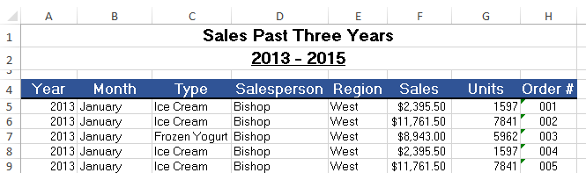

Creating Pivot table and charts 1:

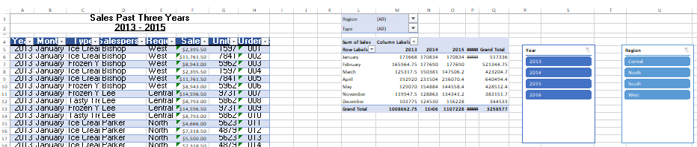

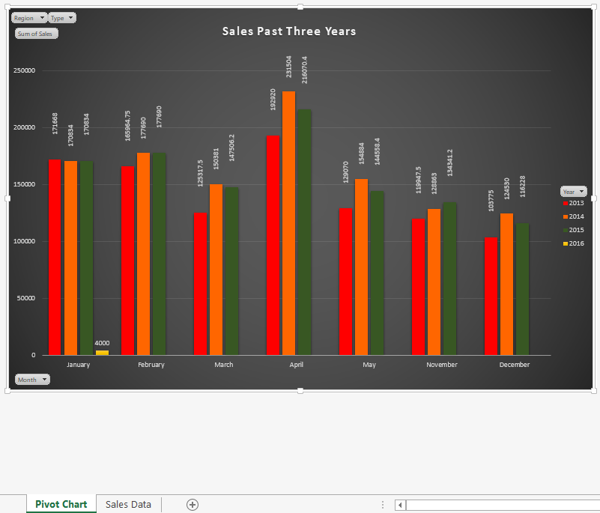

Pivot Table 2:

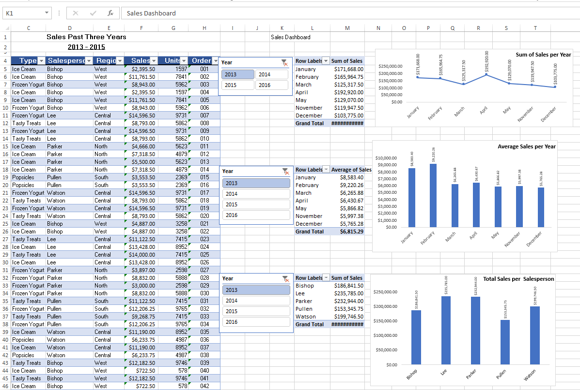

Pivot Chart 2

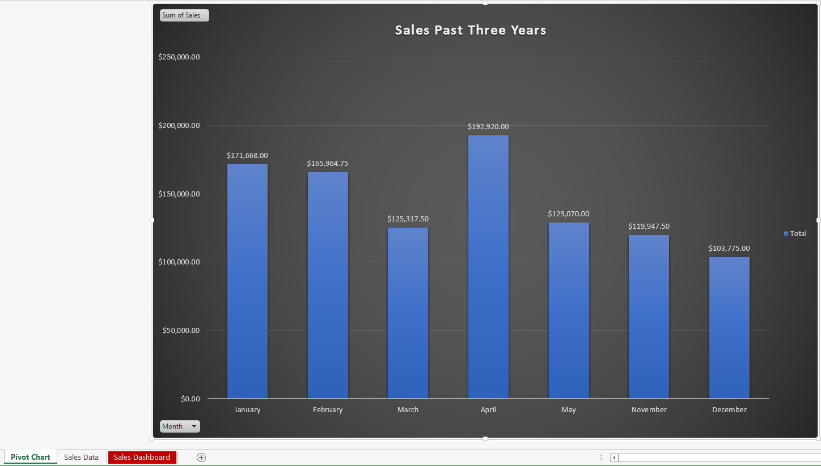

Creating a Dashboard in Excel:

